* When I dig the domain using local DNS and google DNS I got next:

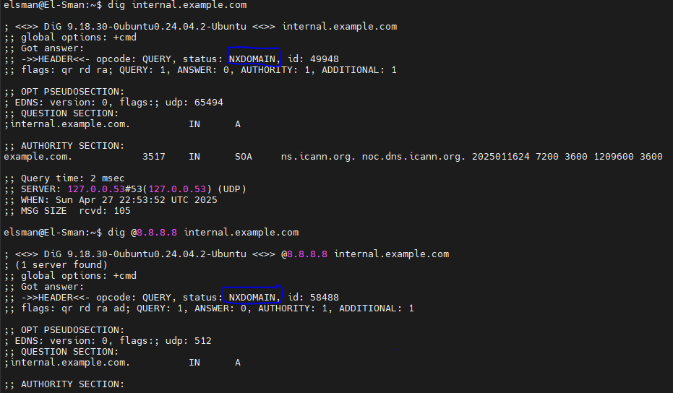

and we found that the response status gives: **NXDOMAIN** in both results refer to that this domain not resolved.

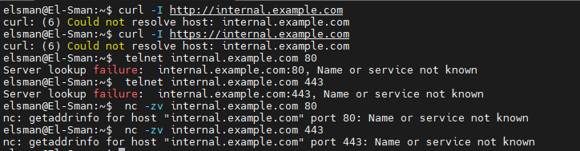

And after editing /etc/hosts and adding 10.0.0.5 internal.example.com for testing at the bottom, and dig again to test   
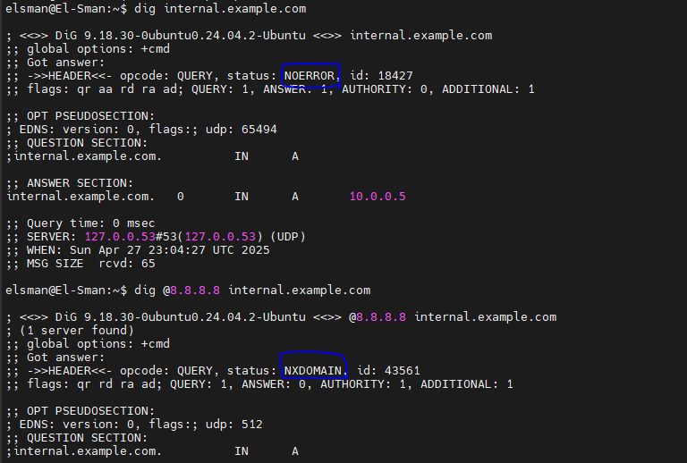

The localhost request status now is NOERROR because we declare this domain on our server, but still google can’t recognize it.

And after curl the 2 requests they gives me

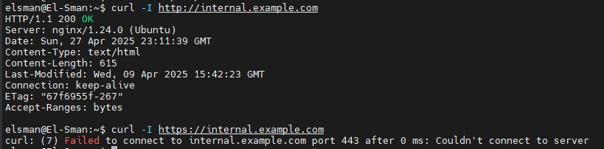

Because we can request the internal domain but we don’t have SSL cert for this domain locally

And so on so

| **Step** | **Check** | **Command** | **Expected** |
| --- | --- | --- | --- |
| 1 | Resolve domain | dig internal.example.com | Should give 127.0.0.1 (or correct IP) |
| 2 | Ping IP | ping -c 3 127.0.0.1 | Should reply |
| 3 | Is port 80/443 open? | `ss -tlnp | grep ':80|:443'` |
| 4 | Curl to IP | curl -I http://127.0.0.1 | Should return HTTP headers |
| 5 | Firewall/iptables | sudo ufw status | Should allow connections |